**Comparative Study On Facial Recognition Algorithms**

**Authors**

| **Sl No** | **Name** | **Designation** | **Email** | **Phone Number** |
| --- | --- | --- | --- | --- |
| 1 | Mrs. Durga Bhavani A | Assistant Professor, Department of CSE, BMSIT | durga842004@bmsit.in | 8951440755 |
| 2 | A Nitya Dyuthi | Student, Department of CSE, BMSIT | nityaa55@gmail.com | 9353704080 |
| 3 | Khushwinder Singh | Student,  Department of CSE, BMSIT | khushwinder99@gmail.com | 9354247571 |
| 4 | Likith S | Student,  Department of CSE, BMSIT | likithsrinath2000@gmail.com | 8310887310 |
| 5 | Prakhyat | Student,  Department of CSE, BMSIT | prakhyat13@gmail.com | 9632440294 |

**Abstract**

In this survey, we compare various facial recognition algorithms objectively and analyze them to find out the best algorithm available. The algorithms will be compared based on the factors: accuracy, architecture, the dataset used to train them, and loss functions. We will compare multiple 2-D facial recognition algorithms such as VGG19, Facenet by Google, Deep face by Facebook, Alexnet, and Local Binary Pattern Histogram (LBPH) and 3-D facial recognition algorithms based on LBP and amalgamation of various Techniques. We will also observe how Big data is utilized in the training of facial recognition algorithms.

**Keywords**

Face Recognition, Comparative study of facial recognition algorithms, Alexnet, Deepface, VGG, Local Binary Pattern.

**Introduction**

Biometrics are measures of human characteristics that are utilized to corroborate identity. The identifying characteristics are almost impossible to impeccably imitate, duplicate, or copy, making them one of the best seekers for adding user authentication security. Facial biometric data, in particular, has shown great pledges for authentication uses, owing to the ease with which user faces can be perceived and linked by the systems.

More than ever before, facial recognition is in the spotlight. Previous historical events have caused a rapid increase in face recognition investments. Given the global COVID-19 epidemic, we may see increased investment in biometric technologies such as facial recognition. Because COVID-19 is so contagious, there is a strong emphasis on contactless interactions. Face recognition technology is still primarily used for security purposes. Facial recognition is widely acknowledged as one of the most accurate and simple methods of establishing individual identity in a variety of industries.

Face recognition has a number of advantages over other biometric modalities in certain situations. It's extensively accepted, veritably familiar, and fluently understood by the general public. As a result, it has a wide range of operations, including felonious identification, unleashing mobile phones and laptops, real-time monitoring security and home access, finding absconding humans, aiding eyeless humans, and feting people on social media, and operation systems, disease diagnosis, among numerous other operations.

**Context**

There have been several algorithms and strategies to recognize faces in the context of face recognition over the years. It is constantly improving as a result of advances in Artificial Intelligence sciences (AI). Even in low-light situations, the accuracy of recognizing complexion, age, gender, and ethnicity has improved. Significant advancements in power, cost, and hardware size enable a wide range of use cases in a variety of industries.

With so many alternatives, the issue isn't "should I adopt a face recognition system?" but "what is the best facial recognition system for me?"

**Literature Survey**

Face detection has been the focus of many studies for the past two decades. Face detection is a hot topic in research, with a variety of classical and deep learning algorithms being used. Both detection and recognition are hot topics in the academic world lately. Many methods for face detection can yield good accuracy, which shows that most studies in face recognition are near fruition. As a result, there are additional obstacles to overcome in terms of recognition. Face recognition was studied using a holistic one hundred and seventy-one learning methods (eigenface, fisher face, SRC and CRC, etc.) and a local handmade approach (LBP, HD-LBP, etc.) from the early 1990s to the early 2000s.

Later in 2010, deep and shallow learning became admired, and deep learning being the most effective for facial recognition. The Deep Convolutional Neural Network FaceNet is a deep convolutional neural network. On YouTube Faces DB, it reaches a new record accuracy of ninety-nine percent and gives ninety-five percent. FaceNet is used to extract features in the proposed system, and it works by imbedding the features into one hundred and twenty-eight dimensions. After feature extraction, a support vector machine is used as a classifier. For facial recognition, support vector machines (SVMs) outperform Multi-Layer Perceptron (MLP) Classification.

Various other 2-dimensional recognition algorithms like Principle Component Analysis (PCA), Alexnet, VGG19, RESNET, Deep face by Facebook, and Local Binary Pattern (LBP) also evolved with time.

The rapid advancement of three-dimensional sensors has shown a state-of-art face recognition path that may be able to succeed the fundamental limits of two-dimensional technologies. The geometric information provided in three-dimensional facial data could significantly increase recognition accuracy in difficult-to-recognize situations. Many academics focused their attention on three-dimensional face recognition, giving rise to a new research trend.

**Facial Recognition Algorithms**

**Alexnet**

Convolutional Neural Network (CNN), a fairly new established image recognition system that utilizes weights sharing and linking information, local receptive fields like neurons in the brain, and significantly reduces training constraints when compared to different neural networks.

Alexnet boosted CNN's fashionability in computer vision by being victorious in the ImageNet Large Scale Visual Recognition Challenge( ILSVRC).

The net contains eight layers with weights; the first five are convolutional and the remaining three are completely connected. The network maximizes the multinomial logistic retrogression ideal, which is original to maximizing the average across training cases of the log probability of the correct marker under the prediction distribution. The output of the last completely- connected layer is fed to a 1000- way softmax which produces a distribution over the 1000 class markers.

The 2nd, 4th and 5th convolutional layers kernels are connected only to those kernel maps in the former layer which resides on the same GPU. The 3rd convolutional layer kernels are connected to all kernel maps in the 2nd layer. The neurons in the completely- connected layers are connected to all neurons in the former layer. follow The 1st and 2nd convolutional layers are followed by Response- normalization layers. Max- pooling layers follow both the 5th convolutional layer and responses- normalization layers.

To the result of every completely- connected layer and convolutional, the ReLUnon-linearity is applied. The 1st convolutional layer filters the two hundred and twenty-four * two hundred and twenty-four * three input image with ninety-six kernels of size eleven * eleven * three with a stride of four pixels. The 2nd convolutional layer takes as input the (response- regularized and pooled) result of the 1st convolutional layer and filters it with two hundred and fifty-six kernels of size five * five * forty-eight. The 3rd, 4th and 5th convolutional layers are connected without any intermediating pooling or normalization layers. The 3rd convolutional layer has three hundred and eighty-four kernels of size three * three * two hundred and fifty-six connected to the output of the 2nd convolutional layer. The 4th convolutional layer has three hundred and eighty-four kernels of size three * three * one hundred and ninety-two, and the fifth convolutional layer has two hundred and fifty-six kernels of size three * three * one hundred and ninety-two. The completely- connected layers have four thousand ninety-six neurons each.

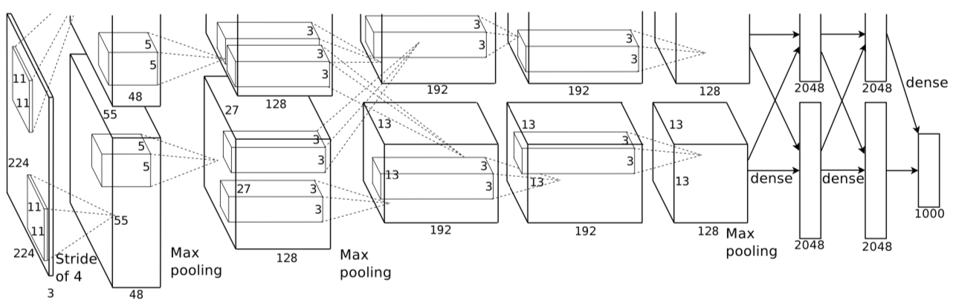

Fig. AlexNet Architecture

**VGG**

AlexNet was released in 2012 and was a bettered traditional Convolutional neural network. VGG can be thought of as an heir to AlexNet, but it was devised by another group called the Visual Figure Group at Oxford. It carries and improves on some ideas from its forerunners and uses deep Convolutional neural layers for better accuracy.

VGG stands for Visual Figure Group. It is one of the most used image recognition model types grounded on deep convolutional neural networks.

The VGG architecture was recognized for achieving top results at the ImageNet challenge. Experimenters at the University of Oxford designed the model.

The VGG- Face has the same architecture as the regular VGG model but it's tuned with facial images. The VGG face recognition model has an accuracy of ninety-seven on the popular Labelled Faces in the Wild( LFW) dataset.

VGG takes in a two hundred and twenty-four * two hundred and twenty-four pixel RGB image. For the ImageNet competition, To keep the input image size harmonious the authors trimmed out the center two hundred and twenty-four * two hundred and twenty-four patches in every image.

VGG Face architecture is as follows:

A fixed-size (two hundred and twenty-four * two hundred and twenty-four) RGB image is given as input to this network. The only preprocessing which is done is the mean RGB value from each pixel is abated, reckoned over the entire training set. The whole notion of the image is covered using Habituated kernels of( three * three ) size with a stride size of one pixel. Spatial padding is used to save the spatial resolution of the image. Max pooling is performed over two * two-pixel windows with side two. Remedied direct unit( ReLu) follows this to bring in non-linearity to make the model classify better and to ameliorate computational time as the former models used tanh or sigmoid functions that proved much better than theirs.

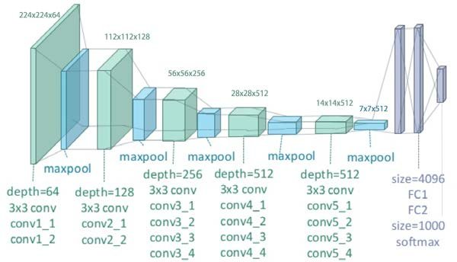

Fig. VGG-Face 19 Architecture

**Deepface by Facebook**

DeepFace is a face recognition system utilized by Facebook for tagging images. It was proposed by experimenters at Facebook AI Exploration( FAIR) at the 2014 IEEE Computer Vision and Pattern Recognition Conference( CVPR).

It uses a deep neural network for facial recognition. It accompanies the inflow of detecting, aligning, representing, and classifying to attain the job. It comprises piecewise affine metamorphosis accompanied by three-dimensional Face Modelling. Latterly, a nine-layer Deep neural Network deduces a face representation. The two-dimensional images are depraved into the three-dimensional plane using the sixty-seven anchor points.

It will not matter whether the face is rotated, at an angle, or in bad lighting. The algorithm differs from former generations of face recognition algorithms that follow the conventional way: detecting→ aligning → representing → classifying. DeepFace employs three-dimensional face modeling and obtains a picture from a deep network of millions of parameters. It uses an algorithm that's able of relating a face with a ninety-seven accuracy. An average human can also do it with a ninety-seven accuracy.

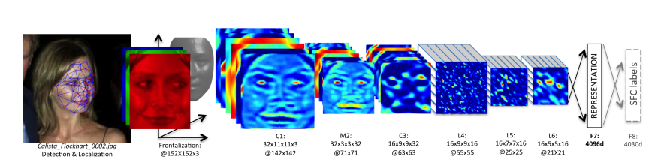

Fig. Architecture of DeepFace

DeepFace is tutored for multi-class facial recognition i.e. to classify the pictures of many people grounded on the individualities.

The input is a three-dimensional-aligned RGB image of one hundred and fifty-two * one hundred and fifty-two. It is also passed into the Convolution layer of size eleven * eleven * three and a three * three maximum- pooling layer with the stride of two with thirty-two filters. Another convolution layer of 16 pollutants and size nine * nine * sixteen follows. The purpose of the layers is to prize lower-position features from the image textures and edges.

The 3 layers are locally attached, a type of completely attached layer that has various types of filters in a different point chart. It helps in perfecting the model because various regions of the face have various demarcation capacities so it's preferable to have various types of point maps to differentiate the facial regions.

The last 2 layers of the model are completely connected. These layers help in setting up a correlation between 2 distant corridors of the face say the position and shape of the eyes and the position and shape of the mouth. The alternate last completely connected layers output is used as a face representation and the output of the last layer is the softmax subcaste K classes for the classification of the face.

**Facenet by Google**

FaceNet is a face recognition system that was expressed by Florian Schroff at Google in the 2015 paper named “ FaceNet A Unified Embedding for Face Recognition and Clustering. ” The FaceNet system is utilized to prize high-quality attributes from faces, called face embeddings, using which a face identification system can be trained. It's a system that works as follows: given a picture of a face, it will prize good-quality features from the face and prognosticate a hundred and twenty-eight element vector representation of these features, called face embedding are generated. The model is a deep convolutional neural network tutored via a triplet loss function which motivates vectors for a similar identity to come more analogous (shorter distance), whereas vectors for separate individualities are anticipated to come less analogous (longer distance).

An important invention in this work was the focus on training a model to produce embeddings directly rather than rooting them from an intermediate subcaste of a model. The face embeddings were also utilized as the base for training classifier systems on ideal face recognition standard datasets, achieving also state-of-the-art results.

This transformation into a simple Euclidean plane clarifies all the tasks as it's a straightforward distance computation. Triplet losses are utilized to grasp the embeddings. The name is deduced from the utilization of 3 images called anchor, positive and negative to learn the mapping. The loss function reduces the distance between the positive and anchor and contemporaneously relocates the anchor and negatives further down.

The Loss is given by

facenet triple loss

Where p is the positive, a is the anchor, n is the negative and α is the periphery executed between +ve and -ve samples.

The architecture is

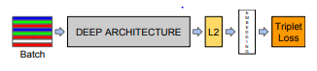

Fig. Architecture of FaceNet

It elaborates that the network is consisting of a deep CNN and a batch input subcaste and is followed by L2 normalization, which results in the generation of face embedding. The triplet loss follows this during training. The figure shows the introductory model of FaceNet. Squared L2 has been utilized to directly match the embedding vectors. By minimizing the triplet loss the embeddings are fine-tuned.

The most significant process is the action of selecting a triplet. The triplets should be chosen in such a way that given an anchor image, choose the “hardest” negative image (of a different person) as in (i.e. the one that’s closest in the dataset) and choose the “hardest ” positive image ( of the same person)(i.e. the one that’s farthest down in the dataset).

There are two different types of Deep architecture utilized i.e the commencement-inspired architecture and the Zeiler Fergus-inspired architecture. The differences lie in the parameters and Duds. The model may differ based on the operation.

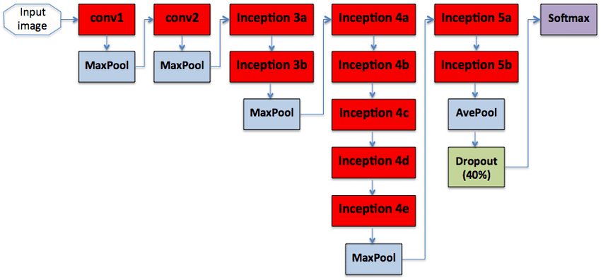

Fig. GoogleNet Architecture

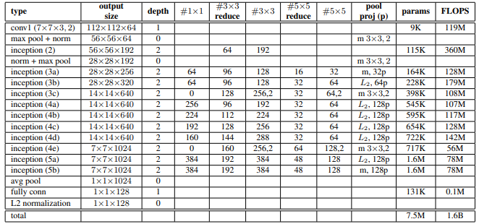

Table. Details of the Facenet Architecture based on GoogleNet

**Local Binary Pattern (LBP)**

Local Binary Pattern (LBP) is a simple yet veritably effective texture driver that labels the pixels of an image by thresholding the neighborhood of each pixel and considers the result as a double number. Due to its discriminational power and computational simplicity, the LBP texture driver has come a popular approach in colorful operations. It can be seen as a unifying approach to the traditionally divergent statistical and structural models of texture analysis. Maybe the most important property of the LBP driver in real-world operations is its robustness to monotonic argentine-scale changes caused, for illustration, by illumination variations. Another important property is its computational simplicity, which makes it possible to dissect images in grueling real-time settings.

It has to be taken into consideration that when the histogram-grounded styles are utilized, the regions don't have to be blockish. They also need not be of the same shape or size, and the whole image doesn't have to be inescapably covered. Incompletely lapping regions can exist. The 2-D face description system has extended into a spatiotemporal sphere. Facial expression descriptions are depicted using LBP- TOP. This approach proved to attain excellent facial expression recognition performance. The face of a person can be recognized from both the frontal face and side face.

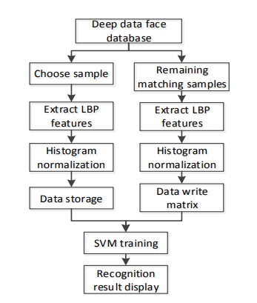

Fig. three-dimensional face Recognition Diagram

One of the fairly prevalent algorithms utilized to classify texture features is Local Binary Pattern( LBP). The texture characteristics of the grayscale image are represented by the LBP driver. LBP has a few advantages that it will have the same characteristics when the viewing angle and firing angle deviate extremely, and it has strong robustness to the light. The most basic local binary mode (LBP) uses the pixel value of the most central point as the threshold value. The expression is as follows

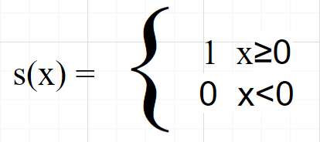

The computation process is as described. Each of the pixels in the image must be taken as the center point and a three* three size area around the pixel must be taken as the neighbcentre. The values of the other eight pixel values in the conterminous area must be compared with the pixel values in the center. Set the pixel value to one, if the pixel value is greater than or equal to the center pixel value, else, set it to zero. An eight-bit unsigned integer double value is formed by generating an eight-bit sequence of zeroes and ones. In the center of this window, the double number is the LBP eigenvalue after computation. The figure illustrates the computation process.

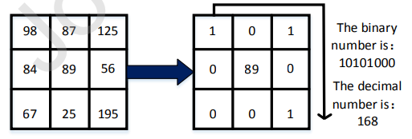

Fig. Schematic diagram of the LBP neighborhood process

The original limited area should be expanded to any size so that the LBP driver has grey invariance and gyration invariance. An indirect neighborhood replaces the original square neighborhood. There can be any number of pixels in the indirect neighborhood, and the circle has a specific gyration invariance as its radius is variable. Thus, the advanced local binary model called circular LBP has gyration invariance.

Each sampling point’s value can be calculated by making use of the formula

Where, (xp,yp) is the sampling point of the area and (xc,yc) is the center point in the neighborhood. Using the above formula, the coordinates of any point in the neighborhood can be found.

**Methodology**

**General Methodology for facial Recognition**

The Algorithms work in accordance with the following steps:

**Step 1:** The camera takes video input.

**Step 2:** The video input is fragmented into images where the face is detected

**Step 3:** The embeddings of the face are generated for training and recognition of the face.

**Step 4:** For a new person to be enrolled, the embeddings are generated which are utilized to train the model using various ML classification algorithms like SVM, K-Nearest Neighbour, Decision Tree, Bayesian Classification, etc.

**Step 5:** The embeddings are then utilized to match and recognize the face from the trained model.

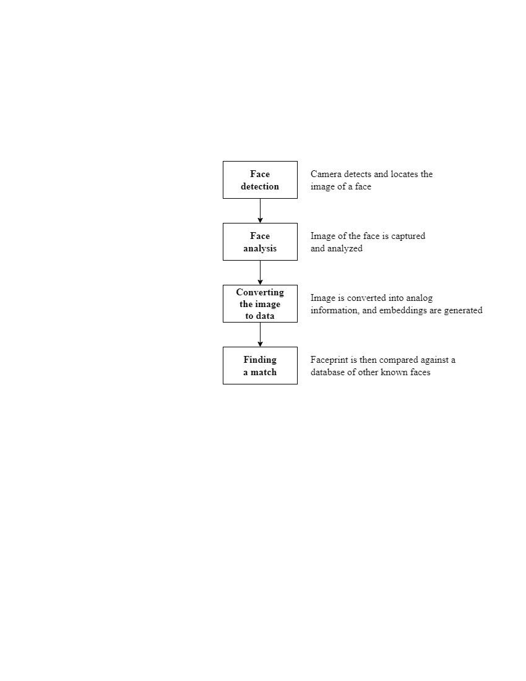

Fig. General Methodology for facial Recognition

**Evaluation**

The evaluation of the algorithms will be done based on the following parameters:

* **Architecture**: CNN architecture is devised by the mound of definite layers that transfigure the input volume into an output volume with the help of a differentiable function. A small change in the architecture can make a huge difference to the final result of the output, hence it's an important parameter when assessing the facial recognition algorithms.
* **The loss function utilized**: The loss function states how training corrects the divagation between the true data markers and the prognosticated output of the network. It plays an important part in the way the model is trained and corrected using the loss values. Different loss functions can be utilized, based on the specified task. It's a salient point of a training algorithm.
* **Dataset utilized for training:** Various datasets can be utilized to train the model with the algorithms. Every dataset has different types of images of the faces in it. The images might be taken in different conditions and angles, and they may also capture different information like emotions, time of the image, angle of capturing, a distance of the person, etc. which make it a prime parameter for evaluation.
* **Accuracy**: It is no doubt the most important parameter for evaluation. The accuracy is the only thing that is highlighted while the evaluation takes place. Almost all the developers adopt the algorithm with a high accuracy rate

**Results**

We will use the parameters defined above to arrive at the results of each algorithm.

**Facial Recognition Algorithms**

| **Sl. no** | **Name of Algo** | **Architecture** | **Dataset used** | **Loss function** | **Accuracy** |
| --- | --- | --- | --- | --- | --- |
| **1** | AlexNet | 8 layers (3 fully connected layers, 5 convolution layers) | ImageNet (15 M Images ) | Cross-entropy | 84.7% |
| **2** | VGG Face 19 | 19 layers (5 MaxPool layers and 1 SoftMax layer, 3 fully connected layers, 16 convolution layers ) | VGGface (2.6 M Images) | Triplet-loss | 98.95% |
| **3** | Deepface | 8 layers (3 fully connected layers, 5 convolution layers) | Facebook(4.4M Images) | Soft-max | 97.35% |
| **4** | Facenet | 22 layers (3 convolution layers, 18 inception layers,1 linear layer) | Google(500M Images) | Triplet-loss | 99.63% |
| **5** | LBP | 3*3 matrix (to evaluate Eigen value) | Texas 3DFRD(5 depth maps per person) | Sparse-categorial-cross-entropy | 96.83 |

From the above table we can observe the following:

* Highest accuracy is obtained by Google’s FaceNet followed by VGGface19
* The largest dataset utilized for training is Google(500 Million images) followed by Imagenet(15 Million)
* The most complex network is utilized by Facenet (GoogleNet-24 - 22 layers) followed by VGGface19 (19 layers).

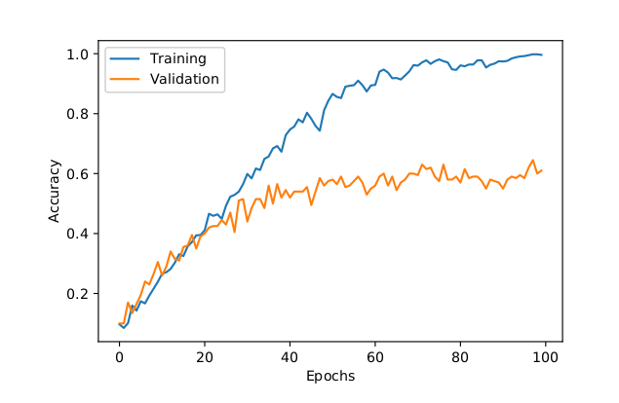

Fig. AlexNet Validation and Training Accuracy

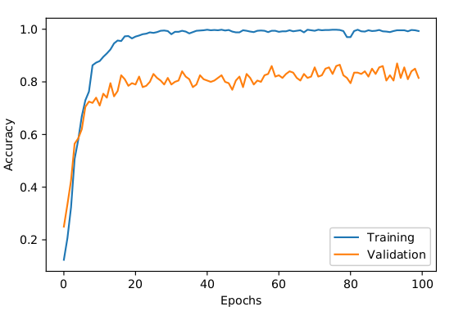

Fig. VGGFace 19 Validation and Training Accuracy

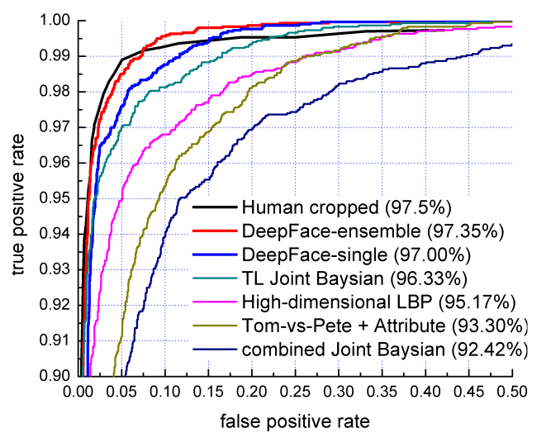

Fig. DeepFace false positive rate vs true positive rate

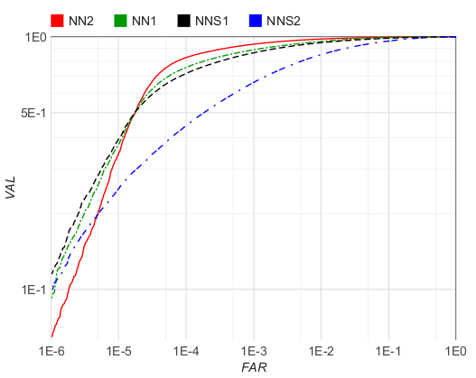

Fig. FaceNet false positive rate vs true positive rate

**Conclusion**

The below conclusions can be made from the results:

* Facenet is the most accurate with an accuracy of 99.63% in 2-D facial recognition algorithms
* Facenet is also the most reliable as it is trained with a dataset of 500 Million images
* VGG Face 19 is also pretty accurate but the dataset size is less
* 3 Dimensional facial recognition captures more features than the 2-dimensional facial recognition algorithms but it is yet to reach the level of accuracy as 2-dimensional recognition algorithms
* In the coming future with better computation and hardware, the demand for 3-dimensional recognition will increase as it is more reliable and trustworthy than 2-dimensional recognition
* We already see big companies like Apple already shifting to 3-d technologies for facial recognition and it is predicted that more and more companies will shift to 3-d technology with improving the accuracy of the algorithms

**References:**

[1] Zhou, S., Xiao, S. 3D face recognition: a survey. Hum. Cent. Comput. Inf. Sci. 8, 35 (2018).

[2]Shi L, Wang X, Shen Y, Research on 3D Face Recognition Method Based on LBP and SVM, Optik (2020)

[3]T. Ahmed, P. Das, M. F. Ali and M. -. F. Mahmud, "A Comparative Study on Convolutional Neural Network-Based Face Recognition," 2020 11th International Conference on Computing, Communication and Networking Technologies (ICCCNT), 2020, pp. 1-5

[4]Chandra, Y.B., & Reddy, G.K. (2020). A Comparative Analysis Of Face Recognition Models On Masked Faces. International Journal of Scientific & Technology Research, 9, 175-178.

[5]Gwyn, Tony, Kaushik Roy, and Mustafa Atay. 2021. "Face Recognition Using Popular Deep Net Architectures: A Brief Comparative Study" Future Internet 13, no. 7: 164.

[6] Suriya Priya R Asaithambi, Sitalakshmi Venkatraman, Ramanathan Venkatraman. Proposed big data architecture for facial recognition using machine learning[J]. AIMS Electronics and Electrical Engineering, 2021, 5(1): 68-92.

[7]A. Verma, P. Singh and J. S. Rani Alex, "Modified Convolutional Neural Network Architecture Analysis for Facial Emotion Recognition," 2019 International Conference on Systems, Signals and Image Processing (IWSSIP), 2019, pp. 169-173

[8]T. Nyein and A. N. Oo, "University Classroom Attendance System Using FaceNet and Support Vector Machine," 2019 International Conference on Advanced Information Technologies (ICAIT), 2019, pp. 171-176

[9]M. Wang, W. Deng, Deep Face Recognition: A Survey, Neurocomputing (2020)

[10]F. Schroff, D. Kalenichenko and J. Philbin, "FaceNet: A unified embedding for face recognition and clustering," 2015 IEEE Conference on Computer Vision and Pattern Recognition (CVPR), 2015, pp. 815-823

[11]Paul, Liton & Suman, Abdulla. (2012). Face recognition using principal component analysis method. International Journal of Advanced Research in Computer Engineering & Technology (IJARCET). 1. 135-139.

[12]Alex Krizhevsky, Ilya Sutskever, and Geoffrey E. Hinton. 2017. ImageNet classification with deep convolutional neural networks. (June 2017), 84–90.

[13]Simonyan, Karen & Zisserman, Andrew. (2014). Very Deep Convolutional Networks for Large-Scale Image Recognition. arXiv 1409.1556.

[14]Y. Taigman, M. Yang, M. Ranzato and L. Wolf, "DeepFace: Closing the Gap to Human-Level Performance in Face Verification," 2014 IEEE Conference on Computer Vision and Pattern Recognition, 2014, pp. 1701-1708